BBA (INFORMATION TECHNOLOGY)
I Year / I Semester
DSC
Programming with C++

SYLLABUS

Unit | Content | Hrs | COs | Cognitive Level
I | Programming Concepts and C++Basics  Programming Concepts: Program, Structured Programming, Object Oriented Programming.  C++ Basics: Introduction to C++, Layout of C++ program, Data types, variables, constants, Keywords, Operators.  Control statements: Branching Statements: if, if-else, nested if, Break, Continue and Switch  statement. Looping Statements: While, Do-while and for Statement. | 12 | CO 1 | Remembering  Understanding
II | Arrays: Introduction, One-dimensional Arrays-Declaration, Initialization, Two-dimensional Arrays-Declaration, Initialization.  Pointers: Introduction, Uses of pointer, Declaring Pointer Variables, Initialization of Pointer Variables, Accessing a Variable through its Pointer. | 12 | CO 2 | Remembering  Understanding
III | Functions: Introduction, definition of function, Built-in functions, User defined functions:  Elements of Functions, Parameter Passing and Recursive Functions  Object & Classes: Features of Object Oriented Programming, Class specification, Access Specifiers, Defining Member Functions, Objects Declaration, Accessing Data Members and Member Functions, Constructors, Destructor, Friend Functions. | 12 | CO 3 | Remembering  Understanding
IV | Templates: Function Templates, Class Templates  Inheritance: Introduction to inheritance, Base Class, Derived class, Types of Inheritance, | 12 | CO 4 | Remembering  Understanding  Analyzing
V | Polymorphism: Function Overloading, Function Overriding, Virtual Functions, Operator Overloading  Exception Handling: Introduction, Exception Handling Mechanism, Handling Multiple Exceptions | 12 | CO 5 | Remembering  Understanding  Analyzing
LAB | Programs on the following concepts  - Control structures  - Arrays  - Classes & Objects  - Constructors  - Templates  - Friend Functions  - Inheritance  - Polymorphism  - Recursion  - Exception Handling | 30 | CO 1  CO 2 CO 3 CO 4 CO 5 | Remembering  Understanding  Applying  Analyzing

C++ was developed by Bjarne Stroustrup, as an extension to the C language. C++ gives programmers a high level of control over system resources and memory.

Difference between procedural programming and object-oriented programming
Object-oriented programming and procedural programming both are used to develop the applications. Both of them are high-level programming languages. These two are important concepts, and it is also important to know the difference between them.
In this article, we will discuss the comparison between procedural programming and object-oriented programming, along with their brief description. It will be helpful and important to the students as this comes as a question in their examinations. So, without more delay, let's start the topic.
Before jumping directly to the comparison, first, see a brief description of both terms.

Procedural Programming
It is defined as a programming language derived from the structure programming and based on calling procedures. The procedures are the functions, routines, or subroutines that consist of the computational steps required to be carried. It follows a step-by-step approach in order to break down a task into a set of variables and routines via a sequence of instructions.
x
During the program's execution, a procedure can be called at any point, either by other procedures or by itself. The examples of procedural programming are ALGOL, COBOL, BASIC, PASCAL, FORTRAN, and C.
As compared to object-oriented programming, procedural programming is less secure. Procedural programming follows a top-down approach during the designing of a program. It gives importance to the concept of the function and divides the large programs into smaller parts or called as functions. Procedural programming is straightforward. Unlike object-oriented programming, there are no access modifiers introduced in procedural programming.

Object-oriented programming
Object-oriented programming is a computer programming design philosophy or methodology that organizes/ models software design around data or objects rather than functions and logic. It includes two words, "object" and "oriented". In a dictionary object is an article or entity that exists in the real world. The meaning of oriented is interested in a particular kind of thing or entity. In layman's terms, it is a programming pattern that rounds around an object or entity.
The programming paradigm where everything is represented as an object is known as a truly object-oriented programming language. Smalltalk is said to be the first truly object-oriented programming language.

Structured Programming
In structured programming, we sub-divide the whole program into small modules so that the program becomes easy to understand. The purpose of structured programming is to linearize control flow through a computer program so that the execution sequence follows the sequence in which the code is written. The dynamic structure of the program than resemble the static structure of the program. This enhances the readability, testability, and modifiability of the program. This linear flow of control can be managed by restricting the set of allowed applications construct to a single entry, single exit formats.

Why we use Structured Programming?
We use structured programming because it allows the programmer to understand the program easily. If a program consists of thousands of instructions and an error occurs then it is complicated to find that error in the whole program, but in structured programming, we can easily detect the error and then go to that location and correct it. This saves a lot of time.
These are the following rules in structured programming:

Structured Rule One: Code Block
If the entry conditions are correct, but the exit conditions are wrong, the error must be in the block. This is not true if the execution is allowed to jump into a block. The error might be anywhere in the program. Debugging under these circumstances is much harder.
Rule 1 of Structured Programming: A code block is structured, as shown in the figure. In flow-charting condition, a box with a single entry point and single exit point are structured. Structured programming is a method of making it evident that the program is correct.
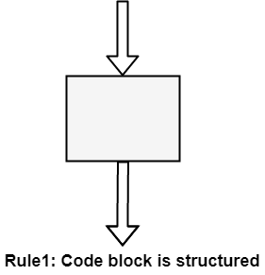

Structure Rule Two: Sequence
A sequence of blocks is correct if the exit conditions of each block match the entry conditions of the following block. Execution enters each block at the block's entry point and leaves through the block's exit point. The whole series can be regarded as a single block, with an entry point and an exit point.
Rule 2 of Structured Programming: Two or more code blocks in the sequence are structured, as shown in the figure.
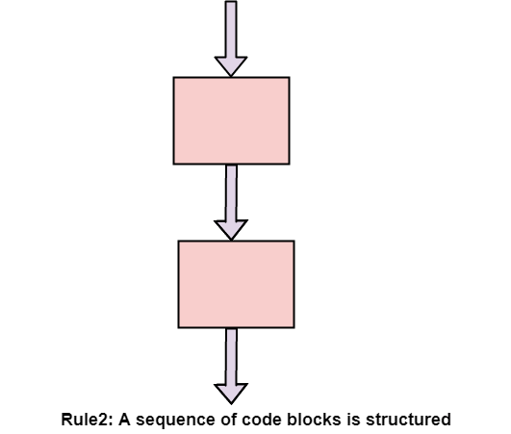

Structured Rule Three: Alternation
If-then-else is frequently called alternation (because there are alternative options). In structured programming, each choice is a code block. If alternation is organized as in the flowchart at right, then there is one entry point (at the top) and one exit point (at the bottom). The structure should be coded so that if the entry conditions are fulfilled, then the exit conditions are satisfied (just like a code block).
Rule 3 of Structured Programming: The alternation of two code blocks is structured, as shown in the figure.
An example of an entry condition for an alternation method is: register $8 includes a signed integer. The exit condition may be: register $8 includes the absolute value of the signed number. The branch structure is used to fulfill the exit condition.
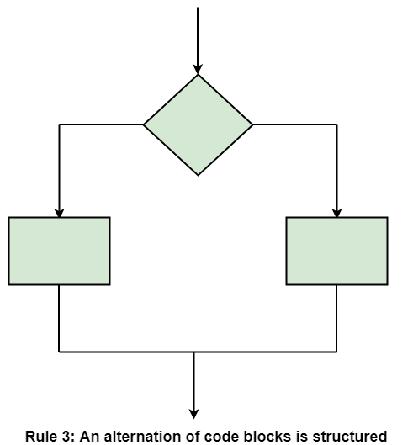

Structured Rule 4: Iteration
Iteration (while-loop) is organized as at right. It also has one entry point and one exit point. The entry point has conditions that must be satisfied, and the exit point has requirements that will be fulfilled. There are no jumps into the form from external points of the code.
Rule 4 of Structured Programming: The iteration of a code block is structured, as shown in the figure.
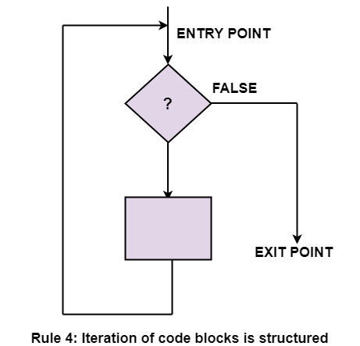

Structured Rule 5: Nested Structures
In flowcharting conditions, any code block can be spread into any of the structures. If there is a portion of the flowchart that has a single entry point and a single exit point, it can be summarized as a single code block.
Rule 5 of Structured Programming: A structure (of any size) that has a single entry point and a single exit point is equivalent to a code block. For example, we are designing a program to go through a list of signed integers calculating the absolute value of each one. We may (1) first regard the program as one block, then (2) sketch in the iteration required, and finally (3) put in the details of the loop body, as shown in the figure.
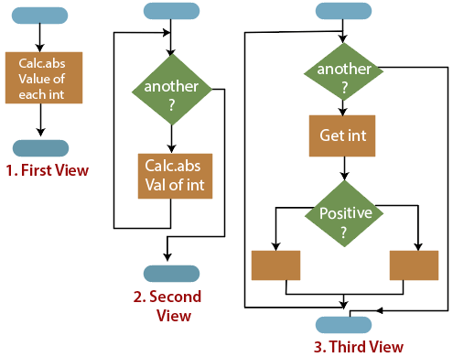
The other control structures are the case, do-until, do-while, and for are not needed. However, they are sometimes convenient and are usually regarded as part of structured programming. In assembly language, they add little convenience.

Overview of C++ language:

1. C++ can be considered as an incremental version of c language which consists all programming language constructs with newly added features of object oriented programming.
2.c++ is structure(procedure) oriented and object oriented programming language.
3.The file extension of C++ program is “.CPP”
4. Function overloading and operator overloading are possible.
5. Variables can be declared in inline i.e when required
6. In c++ more emphasis is give on data rather than procedures
7.Polymorphism, encapsulation and inheritance are possible.
8. Data abstraction property is supported by c++.
9. Data access is limited. It can be accessed by providing various visibility modes both for data and member functions. there by providing data security by data hiding
10.Dymanic binding is supported by C++
11..It supports all features of c language
12.It can be called as an incremental version of c language
sno | Procedure Oriented Programming | Object Oriented Programming
1 | program is divided into small parts called functions | program is divided into parts called objects
2 | Importance is not given to data but to functions as well as sequence of actions to be done. | Importance is given to the data rather than procedures or functions because it works as a real world.
3 | follows Top Down approach. | OOP follows Bottom Up approach
4 | It does not have any access specifier | OOP has access specifiers named Public, Private, Protected, etc
5 | Data can move freely from function to function in the system | objects can move and communicate with each other through member functions.
6 | To add new data and function in POP is not so easy | OOP provides an easy way to add new data and function.
7 | Most function uses Global data for sharing that can be accessed freely from function to function in the system. | In OOP, data can not move easily from function to function,it can be kept public or. Private. so we can control the access of data
8 | It does not have any proper way for hiding  data so it is less secure. | OOP provides Data Hiding so provides more security
9 | Overloading is not possible. | In OOP, overloading is possible in the form of Function Overloading and Operator Overloading.
10 | Example of Procedure Oriented Programming are : C, VB, FORTRAN, | Example of Object Oriented Programming are : C++, JAVA, VB.NET, C#.NET.

Variables in C++

A variable is a name given to a memory location. It is the basic unit of storage in a program.
- The value stored in a variable can be changed during program execution.
- A variable is only a name given to a memory location, all the operations done on the variable effects that memory location.
- In C++, all the variables must be declared before use.

Rules For Declaring Variable:

1.The name of the variable contain letters, digits, and underscores.
2.The name of the variable are case sensitive (ex Arr and arr both are different variable).
3.The name of the variable does not contain any whitespace and special characters (ex #,$,%,* etc).
4.All the variable name must begin with a letter of the alphabet or an underscore(_).
5.We cannot used C++ keyword(ex float,double,class)as a variable name.

How to declare variables?
A typical variable declaration is of the form:
// Declaring a single variable
type variable_name;

// Declaring multiple variables:
type variable1_name, variable2_name, variable3_name;

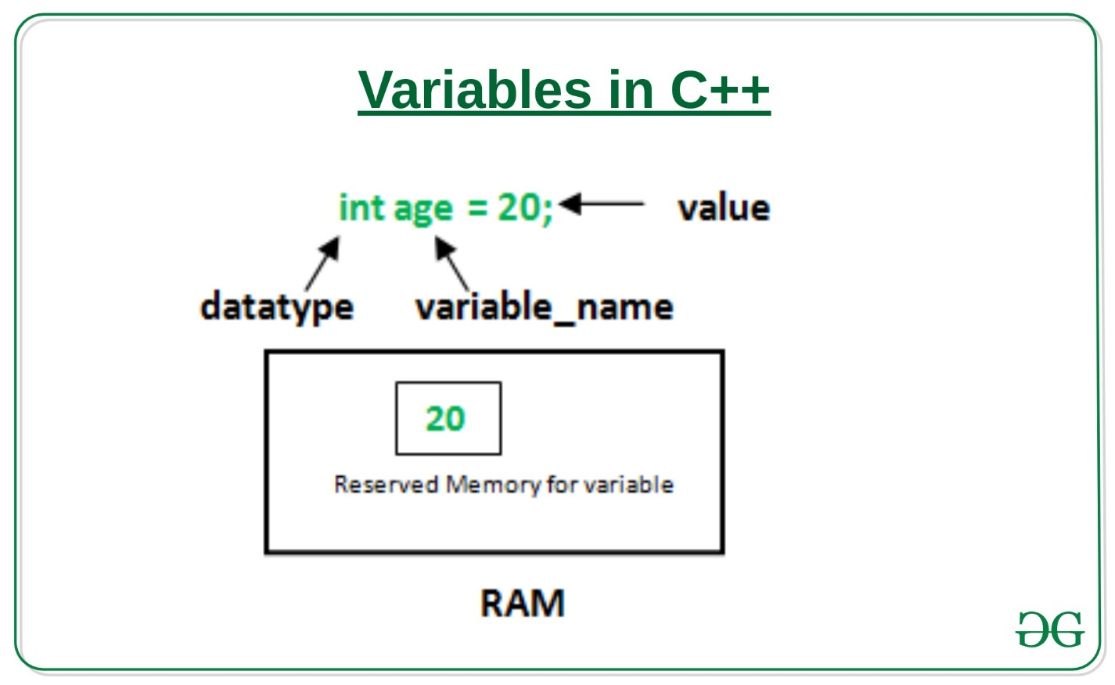

In the above diagram,
datatype: Type of data that can be stored in this variable.
variable_name: Name given to the variable.
value: It is the initial value stored in the variable.
Examples:

syntax:
data type variable1,var2,……;
ex:
int a;
int x,y,z;
float p,q;
char section;
char sname[10];
char gender,cname[10];

Data Types

Data types define the type of data a variable can hold, for example an integer variable can hold integer data, a character type variable can hold character data etc.
Data types in C++ are categorised in three groups: Built-in, user-defined and Derived.
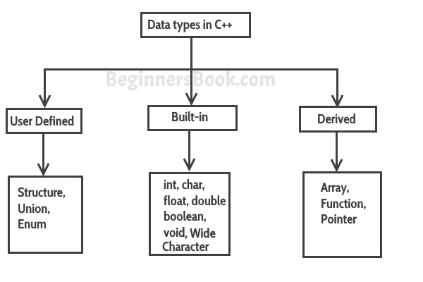

Built in data types
char: For characters. Size 1 byte.
charch = 'A';
int: For integers. Size 2 bytes.
intnum = 100;
float: For single precision floating point. Size 4 bytes.
Float num = 123.78987;
double: For double precision floating point. Size 8 bytes.
Double num = 10098.98899;
bool: For booleans, true or false.
bool b = true;
wchar_t: Wide Character. This should be avoided because its size is implementation defined and not reliable.

User-defined data types
We have three types of user-defined data types in C++
1. struct
2. union
3. enum

Derived data types in C++
We have three types of derived-defined data types in C++
1. Array
2. Function
3. Pointer

C++ Operators
Operators are symbols that perform operations on variables and values. For example, + is an operator used for addition, while - is an operator used for subtraction.
Operators in C++ can be classified into 6 types:
- Arithmetic Operators
- Assignment Operators
- Relational Operators
- Logical Operators
- Bitwise Operators
- Other Operators

1. C++ Arithmetic Operators
Arithmetic operators are used to perform arithmetic operations on variables and data. For example,
a + b;
Here, the + operator is used to add two variables a and b. Similarly there are various other arithmetic operators in C++.
Operator | Operation
+ | Addition
- | Subtraction
* | Multiplication
/ | Division
% | Modulo Operation (Remainder after division)

Example 1: Arithmetic Operators
#include <iostream>
using namespace std;

int main() {
int a, b;
a = 7;
b = 2;

// printing the sum of a and b
cout << "a + b = " << (a + b) << endl;

// printing the difference of a and b
cout << "a - b = " << (a - b) << endl;

// printing the product of a and b
cout << "a * b = " << (a * b) << endl;

// printing the division of a by b
cout << "a / b = " << (a / b) << endl;

// printing the modulo of a by b
cout << "a % b = " << (a % b) << endl;

return 0;
}
Output
a + b = 9
a - b = 5
a * b = 14
a / b = 3
a % b = 1
Here, the operators +, - and * compute addition, subtraction, and multiplication respectively as we might have expected.
/ Division Operator
Note the operation (a / b) in our program. The / operator is the division operator.
As we can see from the above example, if an integer is divided by another integer, we will get the quotient. However, if either divisor or dividend is a floating-point number, we will get the result in decimals.
In C++,

7/2 is 3
7.0 / 2 is 3.5
7 / 2.0 is 3.5
7.0 / 2.0 is 3.5
% Modulo Operator
The modulo operator % computes the remainder. When a = 9 is divided by b = 4, the remainder is 1.
Note: The % operator can only be used with integers.

Increment and Decrement Operators
C++ also provides increment and decrement operators: ++ and -- respectively.
- ++ increases the value of the operand by 1
- -- decreases it by 1
For example,
int num = 5;

// increment operator
++num; // 6
Here, the code ++num; increases the value of num by 1.

Example 2: Increment and Decrement Operators
// Working of increment and decrement operators

#include <iostream>
using namespace std;

int main() {
int a = 10, b = 100, result_a, result_b;

// incrementing a by 1 and storing the result in result_a
result_a = ++a;
cout << "result_a = " << result_a << endl;

// decrementing b by 1 and storing the result in result_b
result_b = --b;
cout << "result_b = " << result_b << endl;

return 0;
}
Output
result_a = 11
result_b = 99
In the above program, we have used the ++ and -- operators as prefixes (++a and --b). However, we can also use these operators as postfix (a++ and b--).
To learn more, visit increment and decrement operators.

2. C++ Assignment Operators
In C++, assignment operators are used to assign values to variables. For example,
// assign 5 to a
a = 5;
Here, we have assigned a value of 5 to the variable a.
Operator | Example | Equivalent to
= | a = b; | a = b;
+= | a += b; | a = a + b;
-= | a -= b; | a = a - b;
*= | a *= b; | a = a * b;
/= | a /= b; | a = a / b;
%= | a %= b; | a = a % b;

Example 3: Assignment Operators
#include <iostream>
using namespace std;

int main() {
int a, b;

// 2 is assigned to a
a = 2;

// 7 is assigned to b
b = 7;

cout << "a = " << a << endl;
cout << "b = " << b << endl;
cout << "\nAfter a += b;" << endl;

// assigning the sum of a and b to a
a += b; // a = a +b
cout << "a = " << a << endl;

return 0;
}
Output
a = 2
b = 7

After a += b;
a = 9

3. C++ Relational Operators
A relational operator is used to check the relationship between two operands. For example,
// checks if a is greater than b
a > b;
Here, > is a relational operator. It checks if a is greater than b or not.
If the relation is true, it returns 1 whereas if the relation is false, it returns 0.
Operator | Meaning | Example
== | Is Equal To | 3 == 5 gives us false
!= | Not Equal To | 3 != 5 gives us true
> | Greater Than | 3 > 5 gives us false
< | Less Than | 3 < 5 gives us true
>= | Greater Than or Equal To | 3 >= 5 give us false
<= | Less Than or Equal To | 3 <= 5 gives us true

Example 4: Relational Operators
#include <iostream>
using namespace std;

int main() {
int a, b;
a = 3;
b = 5;
bool result;

result = (a == b); // false
cout << "3 == 5 is " << result << endl;

result = (a != b); // true
cout << "3 != 5 is " << result << endl;

result = a > b; // false
cout << "3 > 5 is " << result << endl;

result = a < b; // true
cout << "3 < 5 is " << result << endl;

result = a >= b; // false
cout << "3 >= 5 is " << result << endl;

result = a <= b; // true
cout << "3 <= 5 is " << result << endl;

return 0;
}
Output
3 == 5 is 0
3 != 5 is 1
3 > 5 is 0
3 < 5 is 1
3 >= 5 is 0
3 <= 5 is 1
Note: Relational operators are used in decision-making and loops.

4. C++ Logical Operators
Logical operators are used to check whether an expression is true or false. If the expression is true, it returns 1 whereas if the expression is false, it returns 0.
Operator | Example | Meaning
&& | expression1 && expression2 | Logical AND.  True only if all the operands are true.
|| | expression1 || expression2 | Logical OR.  True if at least one of the operands is true.
! | !expression | Logical NOT.  True only if the operand is false.
In C++, logical operators are commonly used in decision making. To further understand the logical operators, let's see the following examples,
Suppose,
a = 5
b = 8

Then,

(a > 3) && (b > 5) evaluates to true
(a > 3) && (b < 5) evaluates to false

(a > 3) || (b > 5) evaluates to true
(a > 3) || (b < 5) evaluates to true
(a < 3) || (b < 5) evaluates to false

!(a < 3) evaluates to true
!(a > 3) evaluates to false

Example 5: Logical Operators
#include <iostream>
using namespace std;

int main() {
bool result;

result = (3 != 5) && (3 < 5); // true
cout << "(3 != 5) && (3 < 5) is " << result << endl;

result = (3 == 5) && (3 < 5); // false
cout << "(3 == 5) && (3 < 5) is " << result << endl;

result = (3 == 5) && (3 > 5); // false
cout << "(3 == 5) && (3 > 5) is " << result << endl;

result = (3 != 5) || (3 < 5); // true
cout << "(3 != 5) || (3 < 5) is " << result << endl

. C++ Bitwise Operators
In C++, bitwise operators are used to perform operations on individual bits. They can only be used alongside char and int data types.
Operator | Description
& | Binary AND
| | Binary OR
^ | Binary XOR
~ | Binary One's Complement
<< | Binary Shift Left
n the arithmetic-logic unit (which is within the CPU), mathematical operations like: addition, subtraction, multiplication and division are done in bit-level. To perform bit-level operations in C programming, bitwise operators are used.
Operators | Meaning of operators
& | Bitwise AND
| | Bitwise OR
^ | Bitwise XOR
~ | Bitwise complement
<< | Shift left
>> | Shift right

Bitwise AND Operator &
The output of bitwise AND is 1 if the corresponding bits of two operands is 1. If either bit of an operand is 0, the result of corresponding bit is evaluated to 0.
Let us suppose the bitwise AND operation of two integers 12 and 25.
12 = 00001100 (In Binary)
25 = 00011001 (In Binary)

Bit Operation of 12 and 25
00001100
& 00011001
________
00001000 = 8 (In decimal)

Example #1: Bitwise AND
#include <stdio.h>
int main() {
int a = 12, b = 25;
printf("Output = %d", a&b);
return 0;
}
Run Code
Output
Output = 8

Bitwise OR Operator |
The output of bitwise OR is 1 if at least one corresponding bit of two operands is 1. In C Programming, bitwise OR operator is denoted by |.
12 = 00001100 (In Binary)
25 = 00011001 (In Binary)

Bitwise OR Operation of 12 and 25
00001100
| 00011001
________
00011101 = 29 (In decimal)

Example #2: Bitwise OR
#include <stdio.h>
int main() {
int a = 12, b = 25;
printf("Output = %d", a|b);
return 0;
}
Run Code
Output
Output = 29

Bitwise XOR (exclusive OR) Operator ^
The result of bitwise XOR operator is 1 if the corresponding bits of two operands are opposite. It is denoted by ^.
12 = 00001100 (In Binary)
25 = 00011001 (In Binary)

Bitwise XOR Operation of 12 and 25
00001100
^ 00011001
________
00010101 = 21 (In decimal)

Example #3: Bitwise XOR
#include <stdio.h>
int main() {
int a = 12, b = 25;
printf("Output = %d", a^b);
return 0;
}
Run Code
Output
Output = 21

Bitwise Complement Operator ~
Bitwise complement operator is a unary operator (works on only one operand). It changes 1 to 0 and 0 to 1. It is denoted by ~.
35 = 00100011 (In Binary)

Bitwise complement Operation of 35
~ 00100011
________
11011100 = 220 (In decimal)

Shift Operators in C programming
There are two shift operators in C programming:
- Right shift operator
- Left shift operator.

Right Shift Operator
Right shift operator shifts all bits towards right by certain number of specified bits. It is denoted by >>.
212 = 11010100 (In binary)
212>>2 = 00110101 (In binary) [Right shift by two bits]
212>>7 = 00000001 (In binary)
212>>8 = 00000000
212>>0 = 11010100 (No Shift)

Left Shift Operator
Left shift operator shifts all bits towards left by a certain number of specified bits. The bit positions that have been vacated by the left shift operator are filled with 0. The symbol of the left shift operator is <<.
212 = 11010100 (In binary)
212<<1 = 110101000 (In binary) [Left shift by one bit]
212<<0 = 11010100 (Shift by 0)
212<<4 = 110101000000 (In binary) =3392(In decimal)

Example #5: Shift Operators
#include <stdio.h>
int main() {
int num=212, i;
for (i=0; i<=2; ++i) {
printf("Right shift by %d: %d\n", i, num>>I);
}
printf("\n");

for (i=0; i<=2; ++i) {
printf("Left shift by %d: %d\n", i, num<<i);
}

return 0;
}

Right Shift by 0: 212
Right Shift by 1: 106
Right Shift by 2: 53

Left Shift by 0: 212
Left Shift by 1: 424
Left Shift by 2: 848

Conditional statements, also known as selection statements, are used to make decisions based on a given condition. If the condition evaluates to True, a set of statements is executed, otherwise another set of statements is executed.
The if Statement: The if statement selects and executes the statement(s) based on a given condition. If the condition evaluates to True then a given set of statement(s) is executed. However, if the condition evaluates to False, then the given set of statements is skipped and the program control passes to the statement following the if statement. The syntax of the if statement is
1  2  3  4  5 | if (condition) {  statement 1;  statement 2;  statement 3;  }
The if-else Statement: The if – else statement causes one of the two possible statement( s) to execute, depending upon the outcome of the condition.
The syntax of the if-else statements is
1  2  3  4  5  6 | if (condition) // if part {  statement1;  statement2;  }  else // else part  statement3;
Here, the if-else statement comprises two parts, namely, if and else. If the condition is True the if part is executed. However, if the condition is False, the else part is executed.
To understand the concept of the if -else statement, consider this example.
#include<iostream>

using namespace std;

int main()
{
int x, y;

cout << "Please enter the Two Different Number = ";
cin >> x >> y;
if(x > y)
{ cout << x << " is Greater Than " << y;
}
else if(y > x)
{cout << y << " is Greater Than " << x; }
else
{ cout << "Both are Equal";
}
return 0;
}

Nested if-else Statement: A nested if-else statement contains one or more if-else statements. The if else can be nested in three different ways, which are discussed here.
• The if – else statement is nested within the if part.
The syntax is
1  2  3  4  5  6  7  8  9 | if (condition1) {  statement1;  if(condition2)  statement2;  else  statement3;  }  else  statement4;
• The if-else statement is nested within the else part.

A code segment to determine the largest of three numbers
#include<iostrem.h>
#include<conio.h>
void main()
{int a,b,c;
clrscr();
cout<<”enter any 3 numbers\n”;
cin>>a>>b>>c;
if (a>b) {
if (a>c)
cout<<"a is largest";
}
else //nested if-else statement within else {
if (b>c)
cout<<"b is largest";
else
cout<<"c is largest";
}
if-else-if ladder, also known as the if-else-if staircase, has an if-else statement within the outermost else statement. The inner else statement can further have other if-else statements.
The syntax of the if -e1se- if ladder is
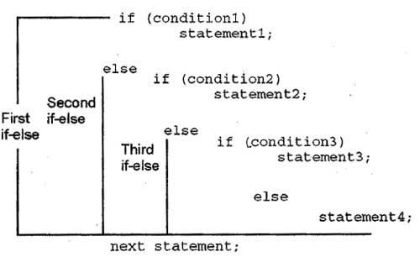To understand the concept of the if-else-if ladder, consider this example.
Example: A program to determine whether a character is in lower-case or upper case
1  2  3  4  5  6  7  8  9  10  11  12  13  14  15 | #include<iostream.h>  using namespace std;  int main() {  char ch;  cout<<"Enter an alphabet:";  cin>>ch;  if( (ch>='A') && (ch<='Z'))  cout<<"The alphabet is in upper case";  else  if ( (ch>=' a') && (ch<=' z' ) )  cout<<"The alphabet is in lower case";  else  cout<<"It is not an alphabet";  return 0;  }
The output of this program is
Enter an alphabet: $
It is not an alphabet
Conditional Operator as an Alternative: The conditional operator ‘? :’ selects one of the two values or expressions based on a given condition. Due to this decision-making nature of the conditional operator, it is sometimes used as an alternative to if-else statements. Note that the conditional operator selects one of the two values or expressions and not the statements as in the case of an if-else statement. In addition, it cannot select more than one value at a time, whereas if-else statement can select and execute more than one statement at a time. For example, consider this· statement.
1 | max = (x>y ? x : y)
This statement assigns maximum of x and y to max
The switch Statement: The switch statement selects a set of statements from the available sets of statements. The switch statement tests the value of an expression in a sequence and compares it with the list of integers or character constants. When a match is found, all the statements associated with that constant are executed.
The syntax of the switch statement
1  2  3  4  5  6  7  8  9  10 | switch(expression)  {  case <constant1>:  statement1;  break;  case <constant2>:  statement2;  break;  case <constant3>:  statement3;  break;  default: statement4;  break;  }  Statement5;
The C++ keywords case and default provide the list of alternatives. Note that it is not necessary for every case label to specify a unique set of statements. The same set of statements can be shared by multiple case labels.
The keyword default specifies the set of statements to be executed in case no match is found. Note that there can be multiple case labels but there can be only one default label.
The break statements in the switch block are optional. However, it is used in the switch block to prevent a fall through. Fall through is a situation that causes the execution of the remaining cases even after a match has been found. In order to prevent this, break statements are used at the end of statements specified by each case and default. This causes the control to immediately break out of the switch block and execute the next statement.
To understand the concept of switch statement, consider this code segment.
Example : A code segment to demonstrate the use of switch statement
#include<iostrem.h>
#include<conio.h>
void main()
{

int x;
clrscr();
cin>>x;

switch(x) {
case l:
cout<<"Option1 is selected";
break;
case 2:
cout<<"Option2 is selected";
break;
case 3:
cout<<"Option3 is selected";
break;
case 4:
cout<<"Option4 is selected;
break;
default:
cout<<"Invalid option!";
}
In this example, depending upon the input, an appropriate message is displayed. That is, if 2 are entered, then the message Option 2 is selected is displayed. In case, 5 is entered, then the message Invalid option! is displayed.
Similar to if and if-else statements, switch statements can also be nested within one another. A nested switch statement contains one or more switch statements within its case labelor default label (if any).
Break and continue statements
In the C ++ programming language, Break and Continue statements are used as Jumps statements in loops. Jumps in loops are used to control the flow of loops. There are two statements used to implement the jump in loops; Continue and Break. These statements are used when we need to change the flow of the loop when a specified condition is met.
The break statement is used to terminate the execution of the current loop. Whenever there is a need to end the loop, you need to add the break statement. Once the break statement is met, all the iterations are stopped, and the control is shifted outside the loop.
The break statement helps with leaving the loop even before its termination condition is met. The break statement basically stops the execution of the loop. Inside the loop body, there is a condition on which you will set the break statement, or you can say on which you want to break the loop; whenever that condition is met, then the execution of the loop is terminated.
include <iostream.h>
usingnamespacestd;

intmain() {
for (int i = 1; i <= 10; i++)
{
// break condition
if (i == 3) {
break;
}
cout<< i <<endl;
}

return0;

continue statement
Continue statements are somewhat similar to break statements. The main difference is that the break statement entirely terminates the loop, but the continue statement only terminates the current iteration
#include <iostream>
usingnamespacestd;

intmain() {
for (int i = 1; i <= 10; i++) {
// condition to continue
if (i == 5) {
continue;
}

cout<< i <<endl;
}

return0;

we will understand the difference between break and continue statements.

break
- It is used to terminate the enclosing loop like while, do-while, for, or switch statement where it is declared.
- It resumes control over the program until the end of the loop.
- It also helps with the flow of control outside the loop.
- It is used with ‘switch’ and ‘label’ since it is compatible.
Following is the flowchart of break statement −
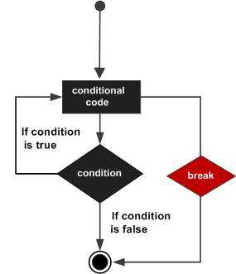

continue
- It helps skip the remaining part of the loop.
- It continues to execute the next iteration.
- It causes early execution of the next iteration of the enclosing loop.
- It can’t be used with ‘switch’ and ‘label’ since it is not compatible.
Following is the flowchart of continue statement −

